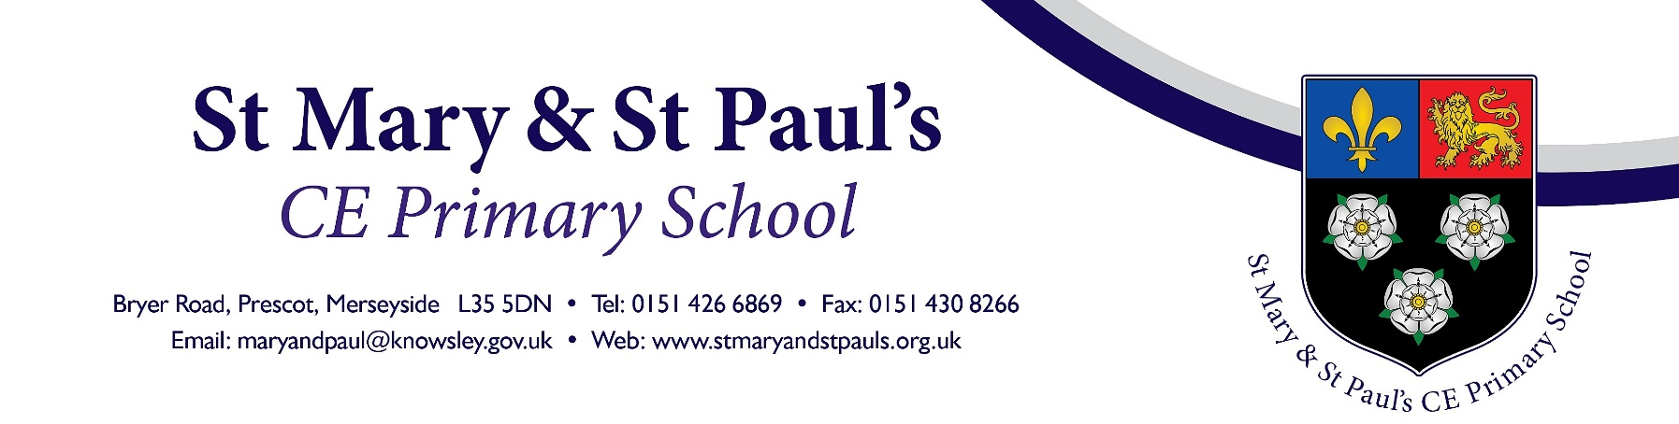

Friday 18th September 2020

Dear Parents and Carers,
RE: Google Classroom

In order to make this home learning easier we are continuing to use a google platform called Google Classroom. This allows us to interact with the children’s learning in a much more dynamic way. We will be able to send links and work that can be completed directly online and you will be able to send it back into us to for the teachers to see it.

Steps to follow
- Download an app (Google Classroom) through either apple or google play called google classroom – it’s free or log on to www.classroom.google.com (If you are unsure watch our youtube clip https://www.youtube.com/watch?v=GUuNnZ5XkZU to see how you can use the desktop version.)
- We will text your child’s login for google classroom. Login and you will have access to the online activities assigned for your classroom.
- Teachers will start to upload homework from this Friday 25th September and if required during any bubble closure or lockdown.

- Complete work, take a photo and upload it (if you want to so that your teacher can see it)
We will try to ensure that work can be completed independently by the children and we do not expect parents to ‘teach’ any new learning. We recommend for children to read as many books as possible, which is a very are worthwhile learning experience.

If you have any questions about the situation, please email admin@stmaryandstpauls.org.uk and we will do our best to respond.

Thank you for your continued patience and understanding

Iain Parks
Headteacher

