Hello Year 2,

I hope you all have had an eggcellent Easter. Mrs James and I have loved making our weekly phone calls and talking to some of you; we have loved hearing about what you have been doing at home and how you are enjoying the sunshine. We are so proud of you all!! Keep being superstars by being safe and we hope you continue to create special memories with your family.

Best wishes

Mrs Ellerton
Reading
“You can find Magic wherever you look. Sit back, relax all you need is a good book!”

Whilst staying in, I have loved reading a range of different books. So far I have read 3 books on my kindle. How many books have you read? Remember you don’t always have to just read a book, you could read a magazine, a picture book and you could even ask your parents or carers to put the subtitles on television when watching your favourite program.

Story time
Listen to the story ‘Through the Magic Mirror’
https://www.youtube.com/watch?v=Hwo36IjsB4o

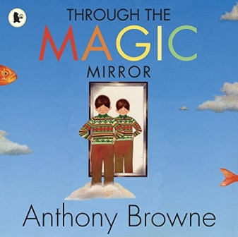
Find a mirror in the house: What can you see? Imagine you are able to walk into the mirror. What do you think you would see? Listen to the story and look at the illustrations in the book and talk about what is different with an adult.

Writing
Inspired by our Chester Zoo visit a few weeks back, so for writing this week can you;

- Can you create an animal alphabet list: Can you think of an animal for each letter of the alphabet?

- Draw a picture of your animal and label it. Can you write sentences using adjectives?

- Write a set of questions about animals you would like to find out about. (Don`t forget your question marks).

- Create a fact file about your favourite animal. Research an animal of your choice and explore the vocabulary required to describe them.

- Describe similarities and differences between animals.

Maths
Length and Measure
Go around your house and measure a range of different objects. You can use a ruler or ask an adult do they have a tape measure. Remember the rule, you must always start with 0 and try to measure in centimetres (cm).
You could measure a range of objects such as your television or tablet, a door, a bath, any furniture or even your family members.
Then could you put all the measurements in order smallest to biggest, could you add all your objects together and also can you find the difference (take away) between objects.
The possibilities are endless.

Times tables
Remember learning our times tables is very important. I have been going on to the `Hit the button` to help me practice my 2s, 3s, 5s and 10s and so far my top score is 30. Do you think you can beat my score?
https://www.topmarks.co.uk/maths-games/hit-the-button

Keeping your mind and body Healthy
Cosmic Kids
Stretch, bend and get movin’ with the Cosmic Kids Yoga YouTube channel, where you’ll find 10-20 minute guided yoga workouts, you will love striking poses in outerspace, underwater, on the farm and more!

Kidz Bop Dance Along
Feel like dancing to popular songs then log onto to follow dance routines and sing along.
https://www.youtube.com/playlist?list=PLMr-d2PLsO95ydptpBnsxdQNSKc9iUNU0

Science
Healthy Foods

In our science lessons, we have been learning about healthy foods and the different food groups. To remain healthy we are meant to eat 5 fruit or vegetables a day. Your task this week is to make a fruit or vegetable animal using a variety of fruit and vegetables.
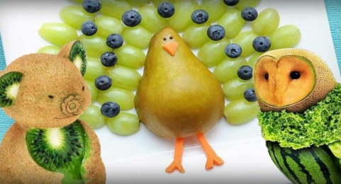

Art
When out in your garden or on a walk can you find a big stone and turn it into a positivity stone, Using paint or felt tips, can you write or draw something that will make someone smile. You could even pass this onto a neighbour or a family member.
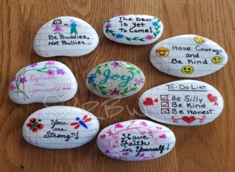
A little extra
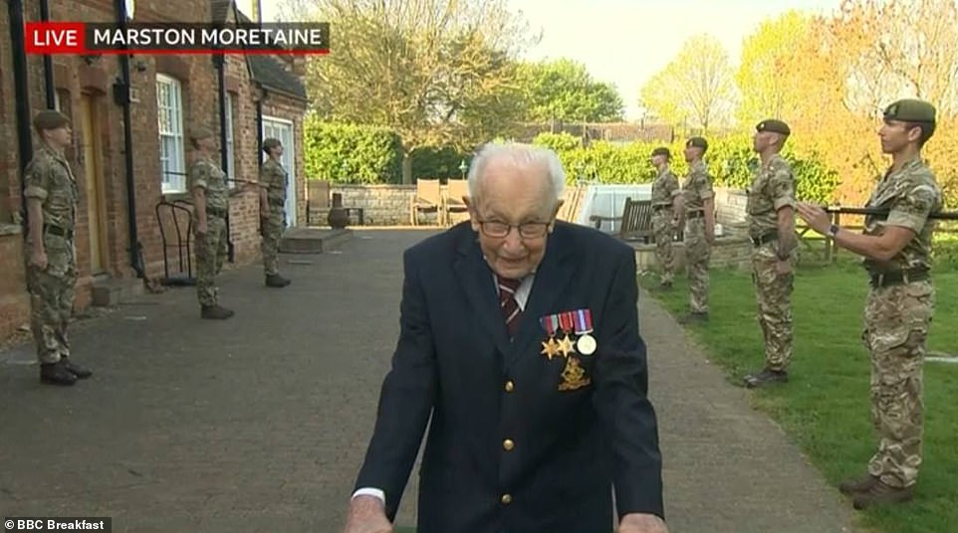
For the past week, I have been keeping a close eye on the outstanding Captain Tom Moore. Captain Tom Moore originally aimed to raise just £1,000 for NHS Charities Together by completing 100 laps of his garden before his 100th birthday. So far he has managed to rise over £16 million.

His birthday is on Thursday 30th April, you could make him a birthday card for his 100th birthday.

