Reading
“Reading is dreaming with your eyes wide open!”
Didn’t we have a great day at the zoo? We enjoyed our visits by Nyarah too.
● Can you read fiction, non- fiction and
poems about animals?
● Can you find adjectives in the books
used to describe the animal?
● Listen to the stories:
https://www.storylineonline.net/books/cl
ark-the-shark/
https://www.storylineonline.net/books/lib
rary-lion/
● Create a bookmark with animal facts
● Read common exception words and
time how long it takes for you to read
them all. Can you beat your score by the end of the week?

Writing
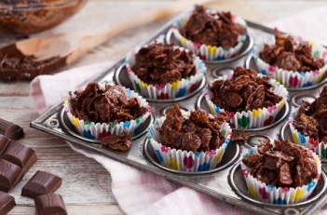
Choose to cook, bake or make something. Then can you write the recipe or instructions to tell somebody else what to do. Remember to use numbers for your steps, to use time connectives (first, then, next, after that, finally) and make sure you use verbs (mix, cut, stick, sprinkle).
Maths
In the past few weeks, we were looking at whole part models and learning our number bonds to 10. Can you earn them ‘off by heart’? You could play ‘Popcorn’.
1st person – 0 2nd person- 10
1st person – 5 2nd person- 5
1st person -4 2nd person -6 etc
Once you’ve learned those perhaps you could learn the number bonds to 20.

Keeping your mind and body Healthy
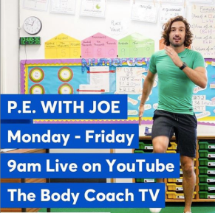
Making sure you and your family are keeping healthy is very important. Every morning at 9.00am, I have been doing the P.E lessons that the body coach has been uploading on his Youtube channel. I have really enjoyed doing the martial arts exercises and you can even pause for a quick break.

Don`t forget some of our favourites websites to work out.
www.gonoodle.com – An adult can create a log in for free and then you can show them our favourite dance routines (Dynamite) and our yoga work outs.

https://www.youtube.com/user/livelovepartyTV - This website has all our favourite wake up, shake up dance routines.
Science
Make your own playdoh. All you need is flour, salt, oil and water! This could also be linked to your writing. https://www.bbcgoodfood.com/howto/guide/playdough-recipe

History
I have loved how enthusiastic you have all been about our learning all about old and new toys. Perhaps you could ask everyone in your house what their favourite toy is. What are the grown up’s favourite toys? Could you look them up on the internet? You could ask questions about how they worked, and what they were made of.

Art
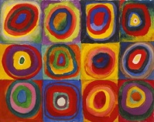
With the clocks going forward, we have more day light hours. Can you take photographs on a phone or tablet of your garden or outside every day? Then can you draw and colour your picture, look to see how the colours change throughout the week.
A little extra
- Help out with some jobs around your home.
- Don`t forget to keep up to date with Newsround https://www.bbc.co.uk/newsround
- Create a playlist with all your family members’ favourite songs.

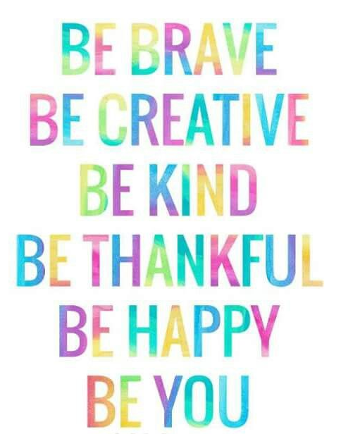
Mrs Humphreys and I are enjoying our phone calls home to you. You are all being very good for your mums and dads and Sharon’s and John’s so keep it up. We are very proud of you. Love from Mrs Craig and Mrs Humphreys.xxxx

