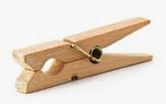

Every day, practice writing your name. Start with your first name then your surname. Make sure the letters are formed correctly

Look at the pictures. Use your phonics and Fred Fingers, then write down the sounds that you hear.

**Reception Week beg 20.04.2020**